**Lab 13 Activity 1 - Creating Forms in HTML**

**Objective** - Learn how to create a basic form with input fields and a submit button.

1. Create a new file named forms.html.
2. Add a <form> element.
3. Insert two <input> fields for user input.
4. Add a submit button (<button>).
5. Use the action attribute to define where the form data is sent.
6. Use the method attribute to specify how data is sent (GET or POST).
7. Save and open the file in a web browser to verify the form

**____________________________________________________________________________________**

**Solutions:**

**Source Code:**

|  |
| --- |
| <!DOCTYPE html> <html lang="en"> <head>  <meta charset="UTF-8">  <meta name="viewport" content="width=device-width, initial-scale=1.0">  <title>Simple Form</title> </head> <body>  <h1>Sample Form</h1>  <form action="/submit-form" method="POST">  <label for="name">Name:</label>  <input type="text" id="name" name="name" required><br><br>  <label for="email">Email:</label>  <input type="email" id="email" name="email" required><br><br>  <button type="submit">Submit</button>  </form> </body> </html> |

**Output:**

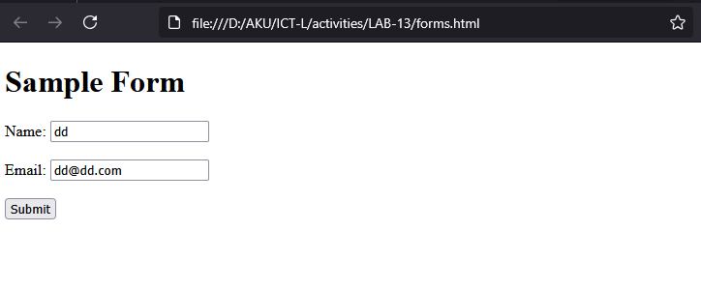

**Analysis:**

* Open “Developer Tools and navigating the Network tab.
* Click submit in the form and see results.